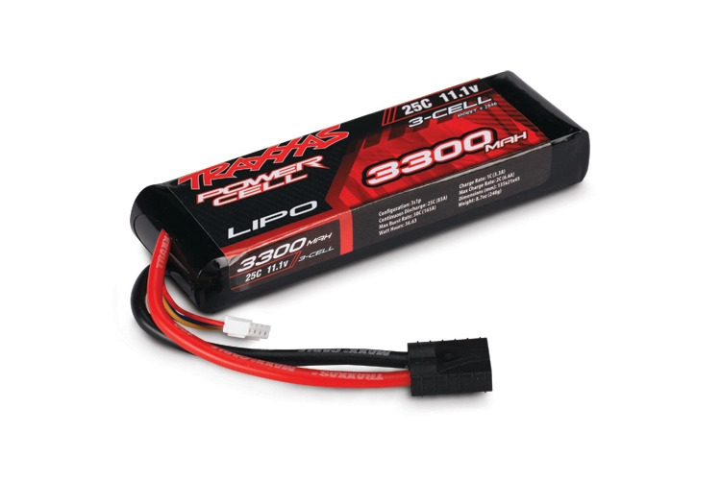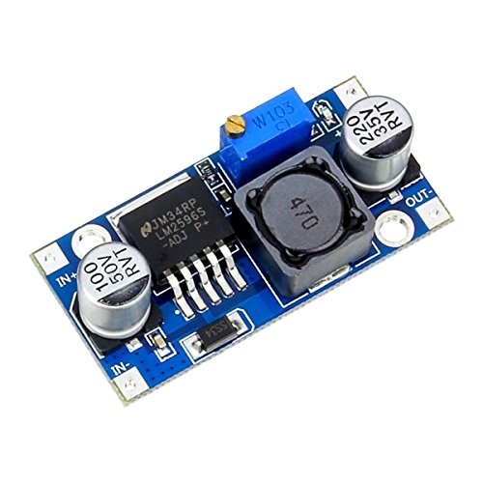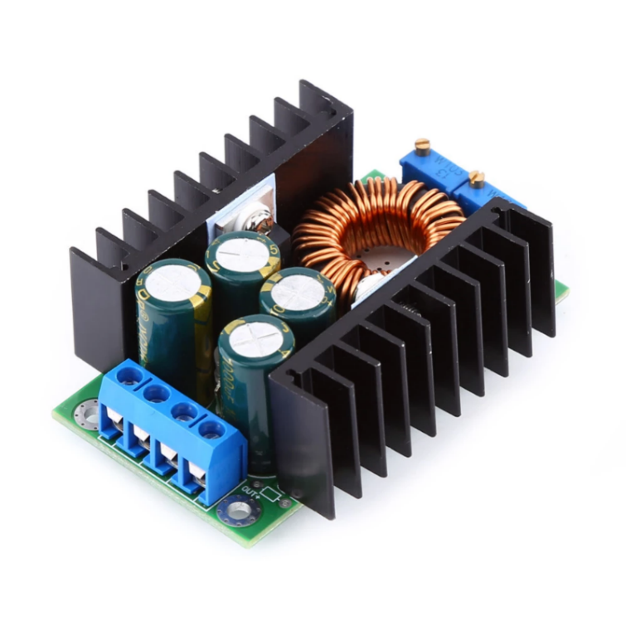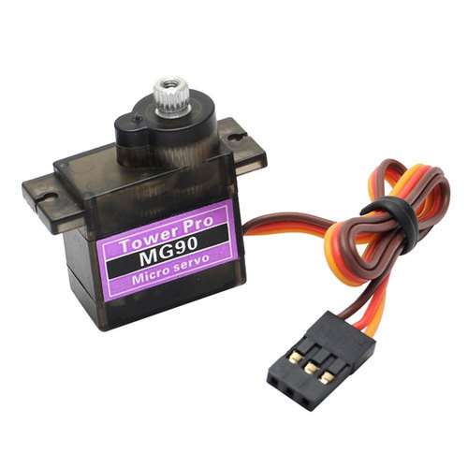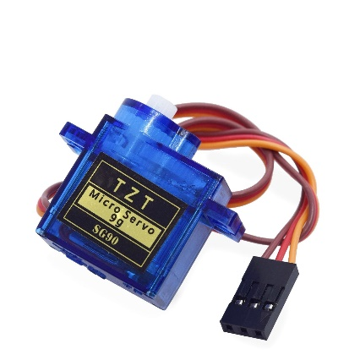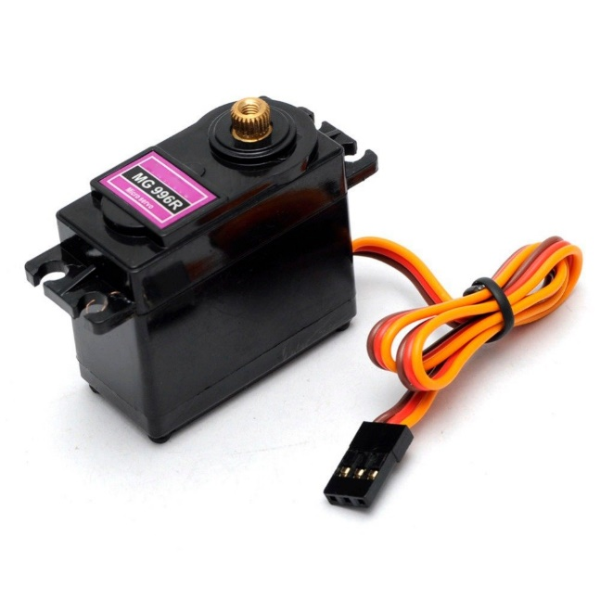0

**LM2596 Step-Down Converter**

**3000mAh LiPo Battery**

**40 C, 11.1 V**

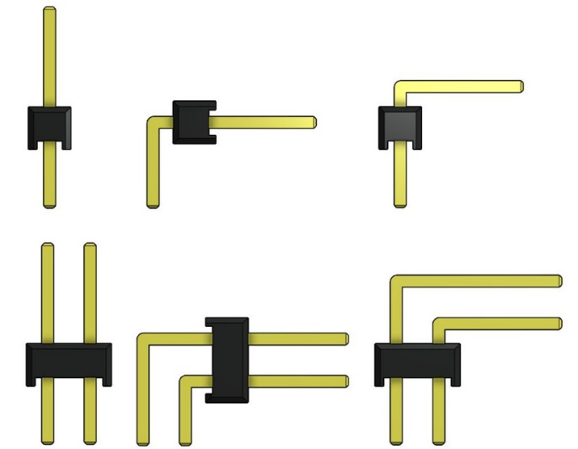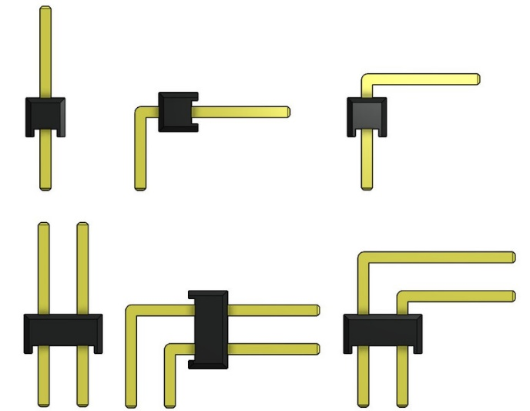

**SG90**

**Servo Motor**

**MG90**

**Servo Motor**

**MG 996R**

**Servo Motor**

**300W Step-Down Converter**

TEAM X-TUMBLER

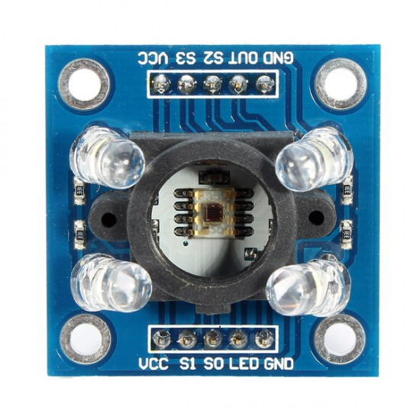

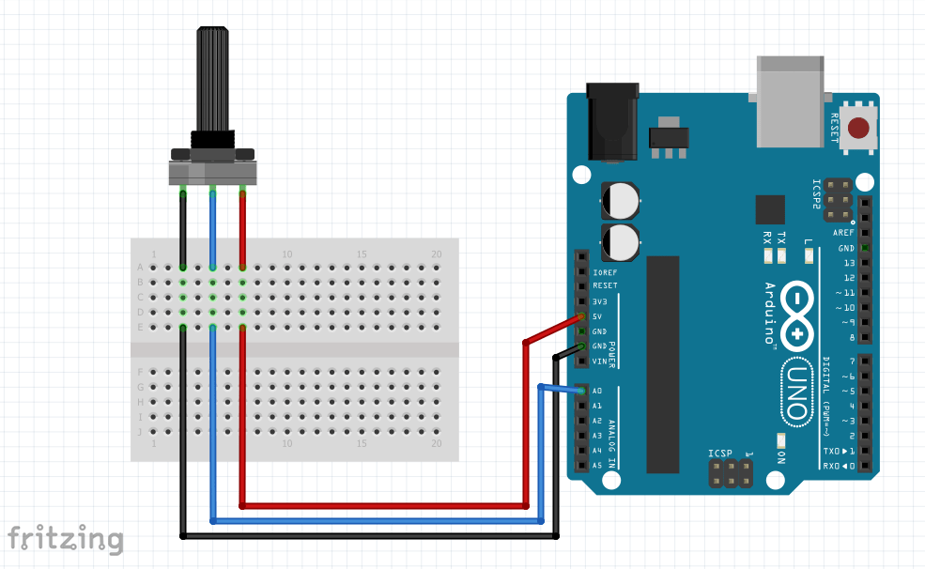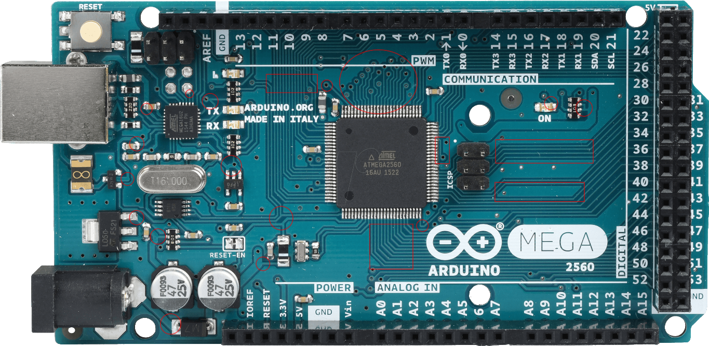

**Potentiometer**

Group No 05

**Pololu VNH5019 Motor Driver**

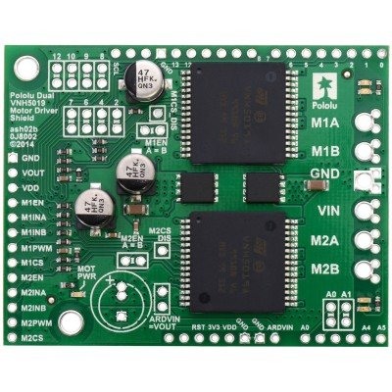

1k

**TCS 3200 Color Sensor**

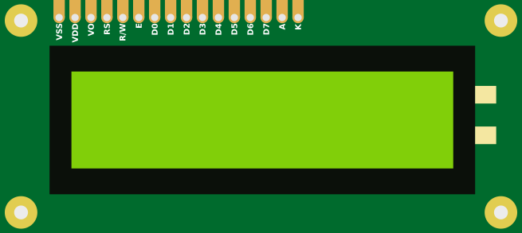

**LCD Display**



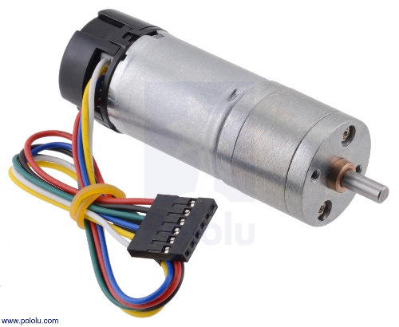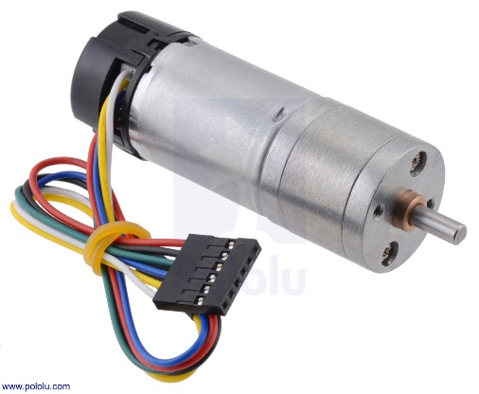

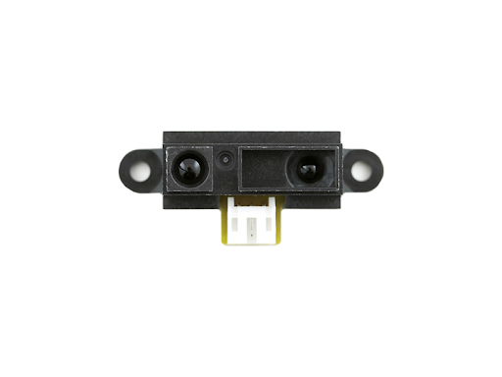

**Motor 1**

**Motor 2**

**GP2Y0A51SK0F**

**Sharp IR**

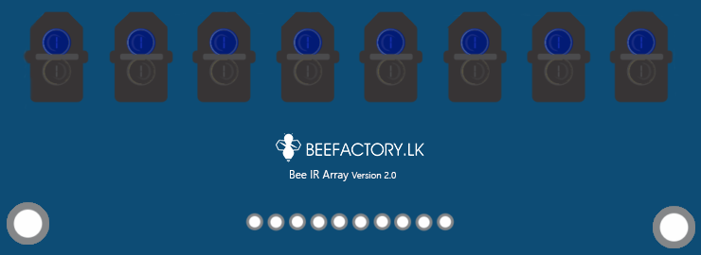

5V

GND

A0

A1

A2

A3

A4

A5

A6

A7

**IR Sensor Panel**

**TCRT 5000**



**GP2Y0A21YK0F**

**Sharp IR**

**GP2Y0A51SK0F**

**Sharp IR**

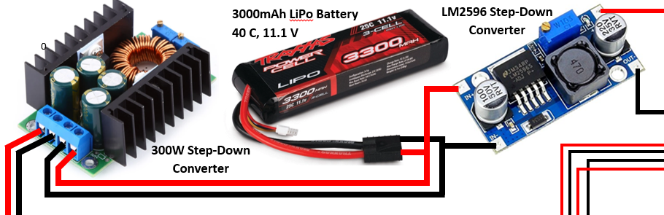

DV Output +5V

DV Output Ground

DV Output Ground

DV Output +9V

DV Input Ground

DV Input +11.1V

Battery and Power Converters

Motor 2 IN PWM

Motor 2 IN B

Motor 2 IN A

Motor 2 Enable

Motor 1 IN PWM

Motor 1 IN B

Motor 1 IN A

Motor 1 Enable

Logic Voltage +5V

Logic Voltage 0V

Motor 1 Encoder Sensor B Vout

Motor 1 Encoder Sensor A Vout

Motor 1 Encoder VCC +5V

Motor 1 Encoder Ground

Motor 2 Encoder Sensor B Vout

Motor 2 Encoder Sensor A Vout

Motor 2 Encoder VCC +5V

Motor 2 Encoder Ground

Motor 2 Ground

Motor 2 VCC +9V

Motor 1 Ground

Motor 1 VCC +9V

Motor 2 Ground

Motor 2 VCC +9V

DC Input +9V

DC Input Ground

Motor 1 Ground

Motor 1 VCC +9V

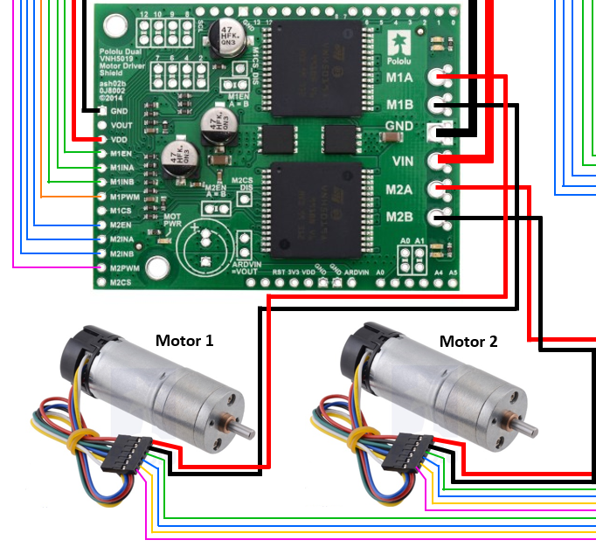

Motors, Motor Driver and Encoders

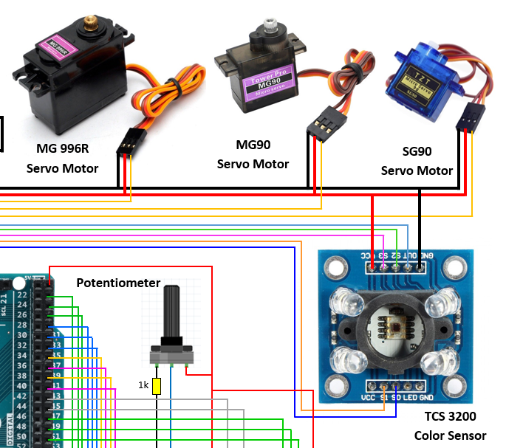

Robot Arm (Servo Motors and Color Sensor)

Output Frequency Scaling Selection Pins

Photodiode Type Selection Pins

Output Frequency

SG90 servo Motor PWM

MG90 servo Motor PWM

MG 996R servo Motor PWM

VCC +5V

Ground

IR Sensor Panel

IR Sensor 7 Output

IR Sensor 6 Output

IR Sensor 5 Output

IR Sensor 4 Output

IR Sensor 3 Output

IR Sensor 2 Output

IR Sensor 1 Output

IR Sensor 0 Output

Sensor Panel Input Ground

Sensor Panel Input +5V

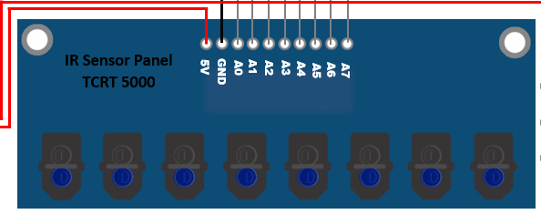

Left Sensor Output

Right Sensor Output

Front Sensor Output

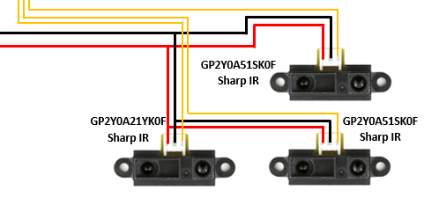

Ground

VCC +5V

Front Sensor

Left Sensor

Right Sensor

Sharp IR sensors (Front, Right and Left)